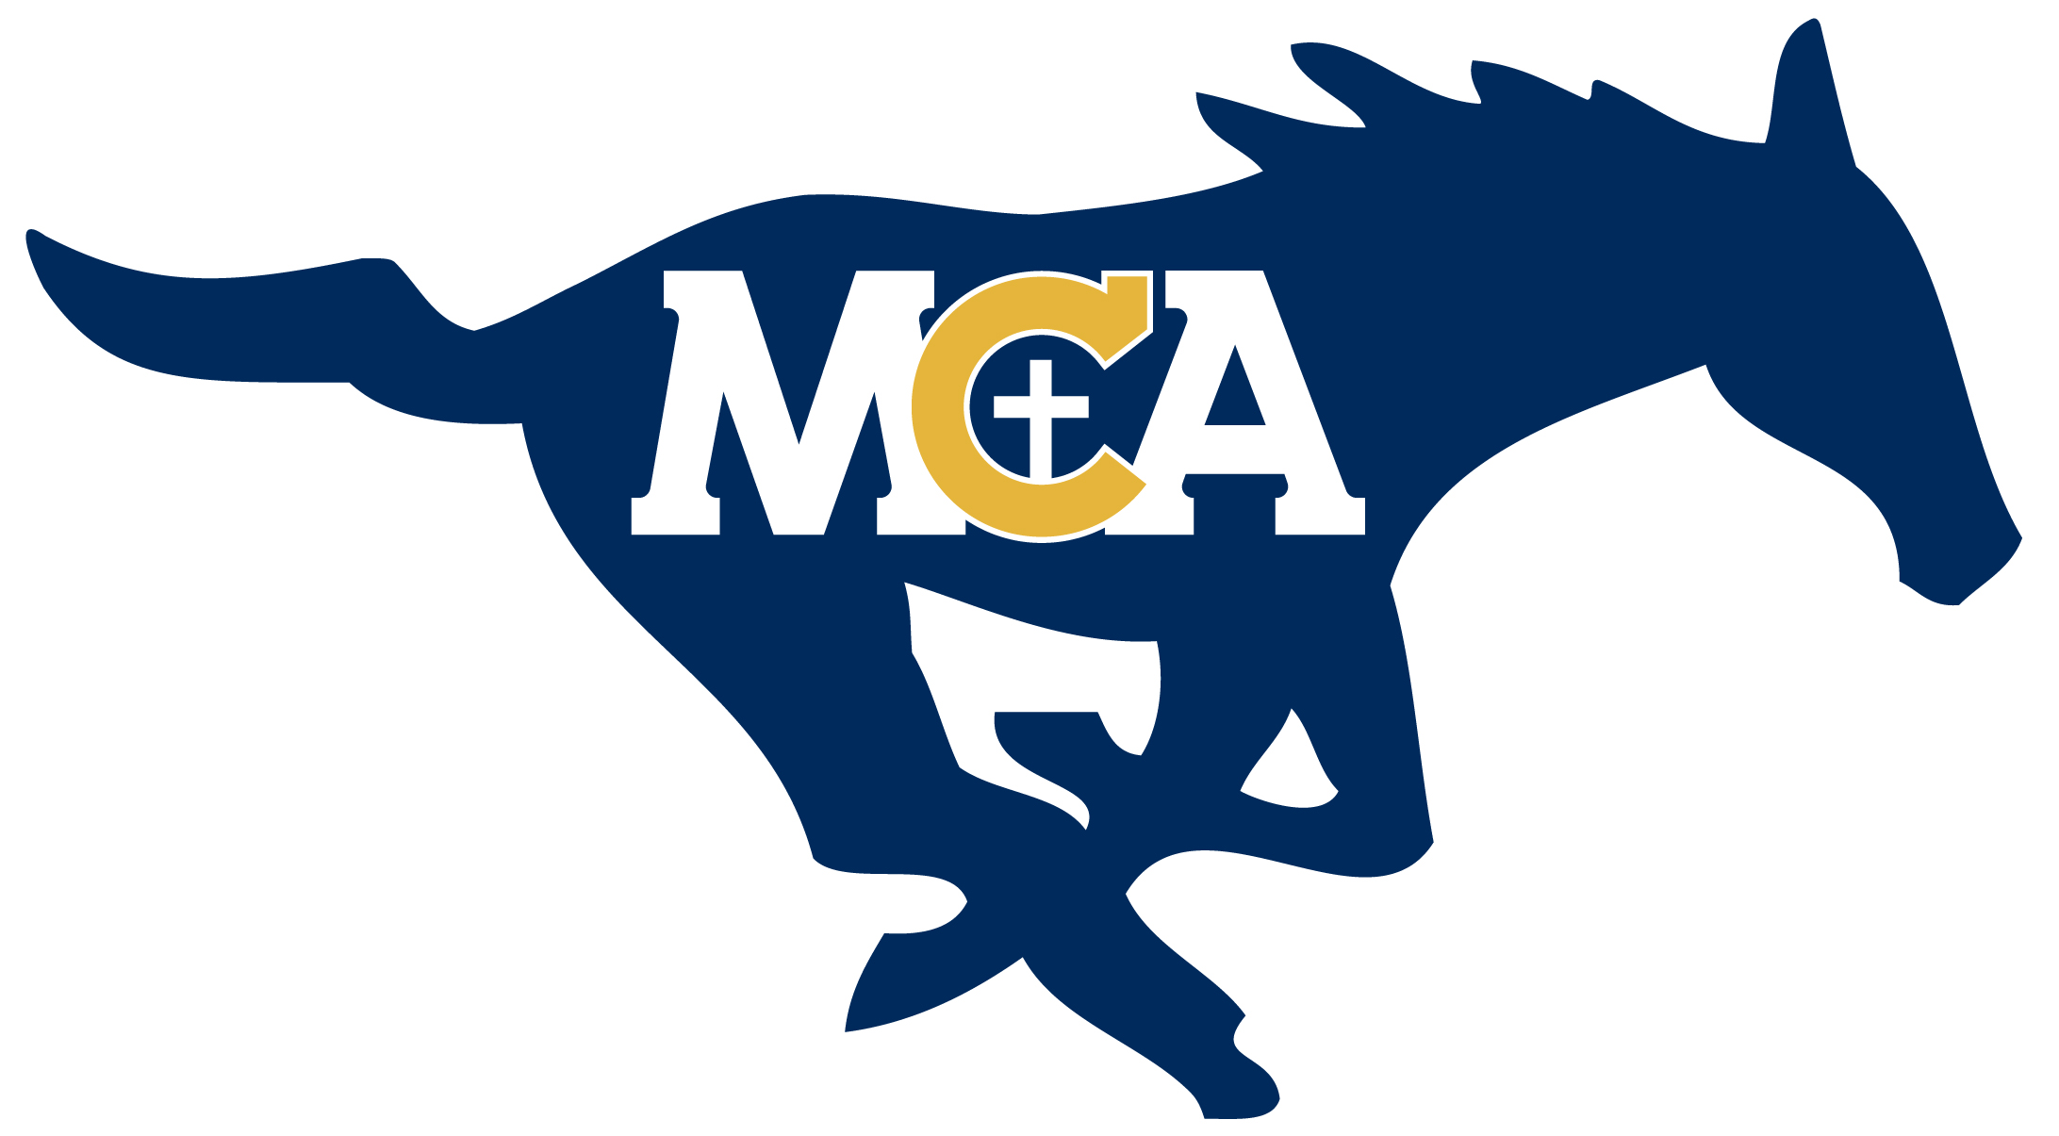

Lil’ Stangs Cheerleading Registration
K-5th Registration Fee: $70 (First Time Fee)
Returning Fee (Wild Week): $35
Returning Fee needs Poms or Shirts: $50
***Please circle your registration fee
***Your FACTS account will be charged.

- Clinic on Saturday, 09/15/2018 from 10am to 12pm in the SLC.
  - Middle School Cheer works with K-2nd grade
  - Varsity Cheer works with 3rd-5th grade
- Li’l Stangs Cheer at Homecoming Tailgate All-School Pep Rally the evening of Thursday, 09/20/2018.
- Li’l Stangs Cheer during the Homecoming Game on Friday, 09/21/2018
  - K-2nd cheer 1st quarter, with Middle School Cheerleaders
  - 3rd-5th cheer 2nd quarter, with Varsity Cheer
  - The cost will include a new pair of pom-poms. The poms will be different than the ones that have been used in the past.
  - The cost will also include a Li’l Stangs T-shirt that the Li’l stangs will wear to the Pep Rally and while they are cheering at the Homecoming Game
  - Clinic on Saturday, 01/12/2019 from 10 am to 12 pm in the SLC.
- Li’l Stangs will cheer during the Wild Week Pep Rally (time/date TBD)
- Li’l Stangs cheer at the Wild Week Basketball Game during the week of 01/20/2019 (game time/date TBD).
  - K-2nd Li’l Stangs will cheer during the 1st quarter of the game
  - 3rd-5th Li’l Stangs will cheer during the 2nd quarter of the game
  - All Li’l Stangs will do a performance during half-time of the game

